Process & Decision Documentation
GBDA 302: Side Quest 4
Student Name: Min Htet Naing, dmnaing (21008098)

Project/Assignment Decisions
Description
For Side Quest 4, I modified the provided Week 4 JSON-driven platformer example to demonstrate data-driven level generation using classes and loops. My goal was to make the level structure and win condition configurable through JSON rather than hard coded in the sketch.

Key Decision / Change
I chose to build on Example 5 because it already integrated JSON-based level data, platform objects, and a blob player with physics. Instead of progressing levels when the player reached the edge of the screen, I added a door object defined in the JSON level data. When the player overlaps with the door, the sketch automatically loads the next level. This made the win condition clearer and tied progression directly to the level structure.
Another key decision was to keep all gameplay logic separate from visual polish. Level structure and progression are handled through JSON and class-based logic, while visual improvements were kept cosmetic to avoid changing the learning focus of the assignment.

GenAI Documentation (Used)
Date Used: Feb 10th, 2026
Tool Disclosure: ChatGPT (GPT-5.2 Thinking)
ChatGPT was used to clarify how to implement a door-based win condition within the existing class structure and to confirm that the modification aligned with the Week 4 JSON + class architecture. It also assisted with minor refactoring suggestions for sketch.js and WorldLevel.js. All final code was reviewed, implemented, and tested manually in VS Code and on GitHub Pages.

Appendix
Prompt 1
“How can I implement a door object in a JSON-based p5.js platformer and detect player overlap to automatically load the next level?”
Answer: 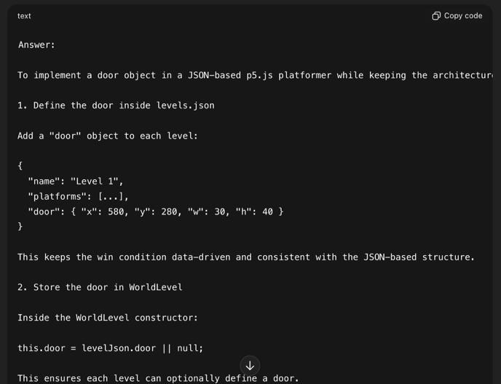
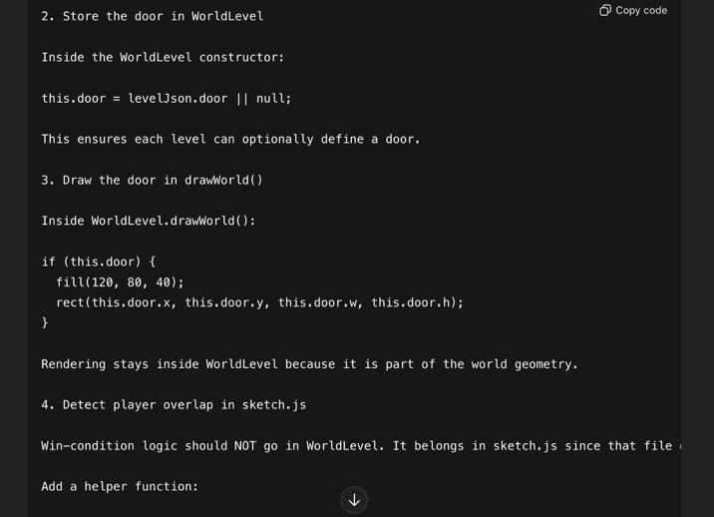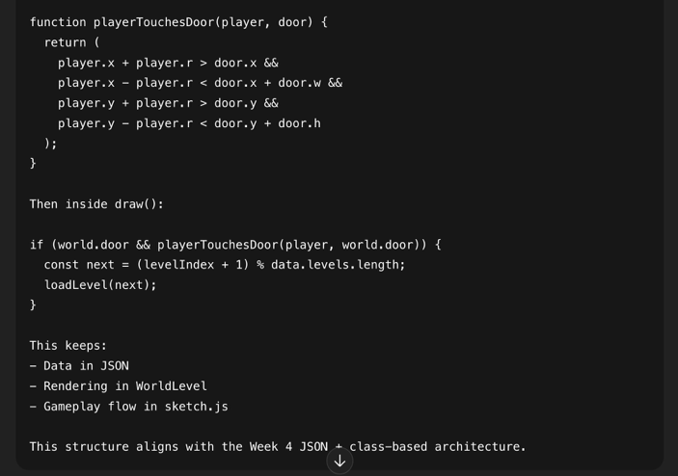
Prompt 2
“Where should squash/stretch animation be added inside a Blob Player class without affecting collision or physics logic?”
Answer:
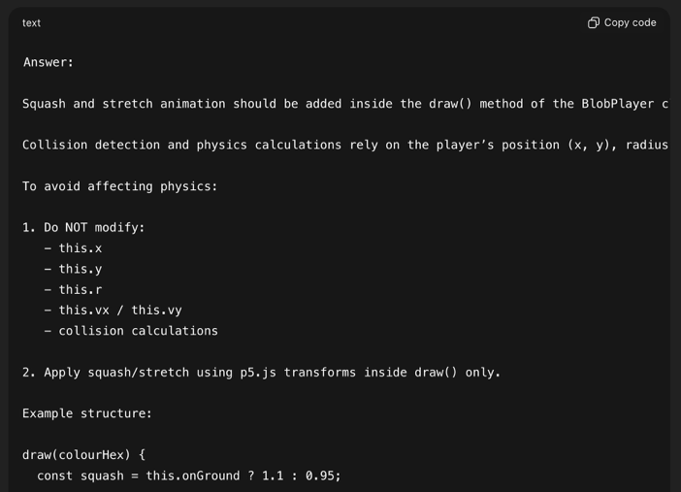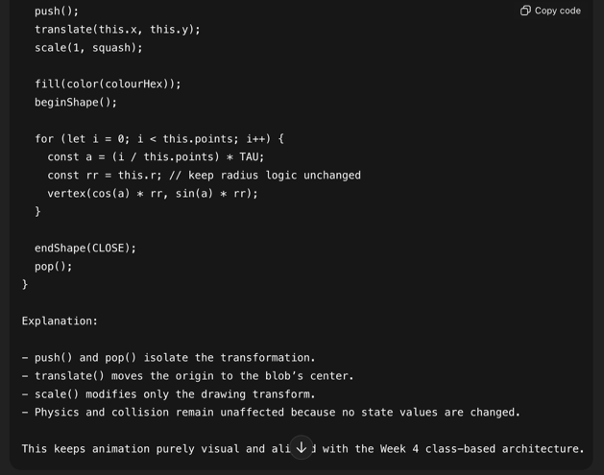
Prompt 3
“Refactor my sketch.js to use door-based level progression instead of screen-edge detection while keeping the architecture modular.”
Answer:
